The Ghulam Ishaq Khan Institute of Engineering Sciences and Technology


AlumNet
Group Members:
Name | Reg numbers
Haider Iqbal | 2023416
Shehroz Majeed | 2023649
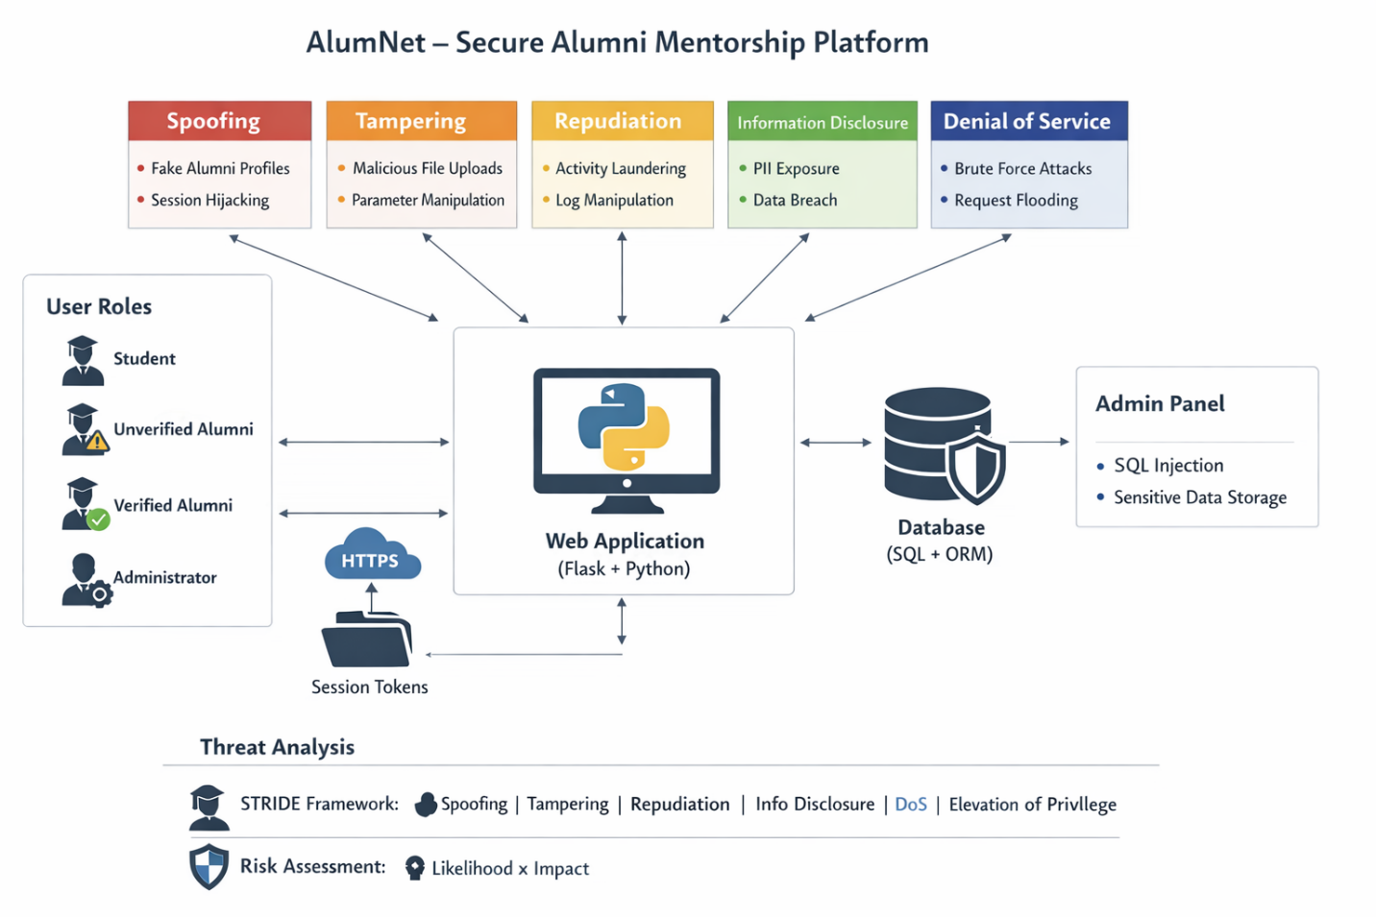

Threat Analysis Summary
The system identifies five primary threat categories impacting various user roles (Student, Unverified Alumni, Verified Alumni, and Administrator):
Threat Category | Specific Risks Identified | Impacted Component
Spoofing | Fake Alumni Profiles, Session Hijacking | User Authentication / Session Management
Tampering | Malicious File Uploads, Parameter Manipulation | Web Application / File System
Repudiation | Activity Laundering, Log Manipulation | Audit Logs / Traceability
Information Disclosure | PII Exposure, Data Breach, Sensitive Data Storage | Database / User Privacy
Denial of Service (DoS) | Brute Force Attacks, Request Flooding | Application Availability
Injection | SQL Injection | Database / Admin Panel

To address the threats visualized in the STRIDE model, the following security controls should be implemented:
1. Authentication & Session Management (Spoofing)
- Multi-Factor Authentication (MFA): Require MFA for all users, especially Administrators and Verified Alumni, to prevent profile spoofing.
- Secure Cookie Attributes: Set session tokens with HttpOnly, Secure, and SameSite=Strict flags to mitigate session hijacking.
- Identity Verification: Implement a robust manual or automated verification process for "Unverified Alumni" before granting "Verified" status.
2. Input Validation & Integrity (Tampering & Injection)
- Parameterized Queries (ORM): Use the integrated ORM (like SQLAlchemy) properly to ensure all database interactions are parameterized, neutralizing SQL Injection.
- File Upload Security: Validate file types (magic bytes, not just extensions), limit file sizes, and store uploads in a non-executable directory or an isolated S3 bucket.
- Checksums: Use digital signatures or hashes for critical data transfers to ensure parameters haven't been manipulated in transit.
3. Audit & Logging (Repudiation)
- Immutable Logging: Stream logs to a centralized storages to prevent log manipulation.
- Comprehensive Telemetry: Log all critical actions (logins, privilege escalations, data exports) with timestamps and unique User IDs.
4. Data Protection (Information Disclosure)
- Encryption at Rest & in Transit: Use AES-256 for sensitive data in the database and enforce TLS 1.3 (HTTPS) for all traffic as shown in the diagram.
- Data Masking: Mask Personally Identifiable Information (PII) in the Admin Panel so that even administrators only see what is necessary for their role.
5. Availability & Rate Limiting (DoS)
- Rate Limiting: Implement Flask-Limiter to restrict the number of requests per IP address, preventing request flooding and brute-force attempts on login endpoints.
- Web Application Firewall (WAF): Deploy a WAF to filter out malicious traffic patterns before they reach the Flask application.

